Academic Performance of Colombian Engineering Students:
Family Background, Gender, and Results on Saber 11 and Saber Pro

Case Study Report, Assignment 1
Prepared for the Department of Education

Qingan Xu
MSSP 6070
9 November 2026

Executive Summary
Engineering students’ results depend strongly on their family background, but almost entirely through the skills they already have when they leave high school. The Department of Education asked for an analysis of these results and for recommendations on directing students’ education. This report therefore analyzes 12,395 Colombian engineering students who took the Saber 11 exam at the end of high school and the Saber Pro exam at the end of their degree.
The three questions have clear answers:
- Parental education (Question 1). It matters, and substantially. Students whose more-educated parent holds a postgraduate degree average 175.3 on the Saber Pro global score, against 154.4 for students whose parents have primary schooling or less. The 20.9-point gap equals 0.95 standard deviations, and parental education explains 7.6% of the variation in scores.
- Strata (Question 2). Stratum 6 performs best, with a mean of 181.5, and the mean rises at every step from stratum 1 (152.4). The strata differ significantly, stratum explains about 10% of the variation, and the gap is widest in English.
- Gender (Question 3). Women and men perform almost equally on the global assessment (161.3 against 163.7; Cohen’s d = −0.10). Men lead in quantitative reasoning and women in written communication.
Saber 11 results explain 61% of the variation in Saber Pro scores. Once they are known, the gaps between the top and bottom background groups shrink to between −0.2 and +1.3 points, and none is statistically significant. University carries the gaps forward; it neither closes nor widens them.
I recommend directing support by measured skills rather than by family background. The department should screen entering students with their Saber 11 results, fund English and mathematics in high schools that serve strata 1 and 2, and address the subject gaps between women and men. Saber 11 results find the students who finish in the bottom quarter twice as precisely as stratum does (69.8% against 35.4%), while flagging 45% fewer students. If support raised the Saber 11 English and mathematics scores of students in strata 1 and 2 by 5 points each, the model predicts a 3.7-point rise in their global scores, closing about a third of their gap with strata 3 to 6.

Introduction
Colombia’s Institute for the Evaluation of Education (ICFES) tests students at two moments: the Saber 11 exam in the final year of high school and the Saber Pro exam in the final year of a university program (Delahoz-Dominguez et al.). Linking the two shows how much results depend on family background, and whether university narrows or widens the gaps that students bring from school. As an analyst for the Department of Education, I was asked to summarize the numerical attributes by category, determine whether results differ by gender, stratum and other attributes, and recommend how to direct the education of students in the various engineering programs. The report answers three questions:
- Does parental education influence outcomes, and if so, how much?
- Which groups or strata perform best, and are there differences between them?
- How does each gender perform in the global assessment?
The evidence is the course file data_academic_performance.xlsx, which the assignment describes as modified from a data set that Enrique De La Hoz published on Mendeley Data (De La Hoz). It holds 12,411 records. Each has five Saber 11 scores (mathematics, critical reading, citizenship competencies, biology and English), five Saber Pro generic modules (quantitative reasoning, critical reading, citizenship competencies, English and written communication), a module on formulating engineering projects and the Saber Pro global score. It also describes the student’s social and economic background, which students report when they register for the exam (Delahoz-Dominguez et al.).
Two background variables are specific to Colombia. Homes are classified into six socioeconomic strata, from 1 (lowest) to 6 (highest), to set the price of public utilities: strata 1 to 3 receive subsidies, and strata 5 and 6 pay a surcharge (“Estratificación socioeconómica”). SISBEN identifies the households that qualify for government subsidies (“Estratificación socioeconómica”; Delahoz-Dominguez et al.).
The current situation shows why the questions matter. Of the students in the file, 46% come from strata 1 and 2, 47% attended a public high school, and 37% of those with a reported parent are the first in their family to study beyond secondary school. The analysis asks whether these students finish their engineering degrees behind their peers, and if so, where the gap arises.
All calculations are in the accompanying Jupyter notebook, written in Python with pandas (McKinney), NumPy (Harris et al.), SciPy (Virtanen et al.) and Matplotlib (Hunter). It runs from top to bottom in Google Colab with no setup and reproduces every number, table and figure in this report (see app. A).

Key Issues, Goals, and Problems
The department’s goal is for every engineering student to graduate with strong skills, and to narrow the gaps linked to family background and gender by spending limited resources where they do the most good. Five issues stand in the way:
- Large socioeconomic gaps. The mean global score is 29.1 points higher in stratum 6 than in stratum 1 (Cohen’s d = 1.33). It is 30.4 points higher for families earning 10 or more minimum wages than for those earning less than one, and 20.9 points higher for students with a postgraduate parent than for those whose parents have primary schooling or less.
- Gaps that form before university. Saber 11 results already show the same gradients, and students mostly keep their rank: 69.8% of the students in the bottom quarter on Saber 11 finish in the bottom quarter on Saber Pro.
- English is the most unequal skill. Stratum explains 25% of the variation in Saber 11 English and 18% in Saber Pro English, against 2% to 10% in the other subjects.
- Opposite gender gaps by subject. Men lead in quantitative reasoning (d = −0.42) and women in written communication (d = +0.17), although overall results are almost equal.
- Imprecise targeting. Background categories are easy to use for eligibility, but only 35.4% of students from strata 1 and 2 finish in the bottom quarter of the global score, while 31.9% of stratum-1 students reach the national top quarter.

Decision Criteria
I judge each way of directing support against six criteria:
- Coverage: the share of the students who finish in the bottom quarter of the global score that the strategy reaches.
- Precision: the share of the students it serves who would otherwise finish in the bottom quarter. Higher precision means less money spent on students who would do well anyway.
- Size of the problem addressed: how large a gap it targets, measured by effect size or by the share of variation explained.
- Timing: whether it acts where the gap forms, before university or during it.
- Cost and feasibility: whether it relies on data the system already collects, such as Saber 11 scores, strata and SISBEN.
- Measurability: whether its effect can be checked against later Saber Pro results and a comparison group.

Assumptions
The analysis rests on six assumptions:
- Scores are comparable. Each exam’s scores mean the same thing for every student, school and university. All students in the file sat Saber Pro in 2018, after sitting Saber 11 in 2012, 2013 or 2014.
- The Saber Pro modules are percentile ranks. The five generic modules run from 1 to 100 and behave like national percentile ranks, although the workbook does not state their scale. The engineering-projects module and the global score use a 0–300 scale.
- Missing codes mean missing. A “0” (not reported) and, for parental education, “Not sure” mean that the answer is missing. Those students stay in every analysis that does not need the missing field.
- Duplicates are repeat sittings. Sixteen Saber Pro records appear twice, each time with two different Saber 11 sittings. I kept the earlier sitting, so each Saber Pro result counts once.
- Zero essay scores are real. The 308 zero scores in written communication are genuine results, most likely blank or unscorable essays. Excluding them does not change the gender comparison.
- Associations size the recommendations; they do not prove them. The regression models describe associations, and I use them only to estimate the scale of the possible gains.

Limitations of the Data
The file is large and internally consistent, but seven limits affect how far the results can be pushed:
- Only students who reached Saber Pro. The file covers only students who completed an engineering program and sat Saber Pro. Students who dropped out are missing, and if they differ most by background, the true gaps are larger than the ones measured here.
- Observational data. The results show which students score higher, not why. Background, school quality and student effort are entangled, so no estimate here is a causal effect.
- Hidden missing values. No cell is blank, but missing answers are coded inside the categories: 7.6% of father’s occupation, 6.4% of father’s education and 4.6% of mother’s education are “0” or “Not sure.” The regression models use the 11,695 students with complete data.
- Gaps in the documentation. For six variables, the workbook’s definitions do not match the data. Family income has 3 documented levels but 8 in the data, work while studying 8 against 4, and academic program 23 against 21. The workbook also does not state the scale of the Saber Pro modules.
- A modified extract. The assignment describes the course file as modified from the published data set (De La Hoz), so its figures may differ from other versions.
- One Saber Pro year. All students sat Saber Pro in 2018, so the results describe one group of graduates. Students who reached Saber Pro fastest (Saber 11 in 2014) scored highest, 175.8 against 158.1 for the 2012 sitting, which may reflect who finishes quickly rather than what they were taught.
- Coarse background measures. Income is recorded in bands of the minimum wage, and stratum classifies the home rather than measuring the family’s income.

Data Analysis
This section first summarizes the numerical attributes by category, then answers the three questions in order and examines what else is associated with results. Supplementary tables are in the appendices, and the full code is in the notebook.

Numerical Attributes by Category
Compared with all Saber Pro test takers, these engineering students score well (see table 1). Their Saber 11 means range from 60.7 in citizenship competencies to 64.3 in mathematics on the 0–100 scale. On Saber Pro, their median national percentile is 85 in quantitative reasoning but 56 in written communication, and 50.9% of them reach the national top quarter of the global score (163 points or more).
Table 1
Scores of 12,395 Engineering Students on Saber 11 and Saber Pro
Exam | Subject | Scale | Mean | Std. dev. | Minimum | Median | Maximum
Saber 11 | Mathematics | 0–100 | 64.3 | 11.9 | 26 | 64 | 100
 | Critical reading | 0–100 | 60.8 | 10.0 | 24 | 61 | 100
 | Citizenship competencies | 0–100 | 60.7 | 10.1 | 0 | 60 | 100
 | Biology | 0–100 | 64.0 | 11.2 | 11 | 64 | 100
 | English | 0–100 | 61.8 | 14.3 | 26 | 59 | 100
Saber Pro | Quantitative reasoning | Percentile | 77.4 | 22.7 | 1 | 85 | 100
 | Critical reading | Percentile | 62.2 | 27.7 | 1 | 67 | 100
 | Citizenship competencies | Percentile | 59.2 | 29.0 | 1 | 65 | 100
 | English | Percentile | 67.5 | 25.5 | 1 | 74 | 100
 | Written communication | Percentile | 53.7 | 30.0 | 0 | 56 | 100
 | Engineering projects | 0–300 | 145.5 | 40.1 | 1 | 153 | 300
 | Global score | 0–300 | 162.7 | 23.1 | 37 | 163 | 247
Source: Author’s calculations from data_academic_performance.xlsx (De La Hoz). The percentile modules appear to be national percentile ranks; the workbook does not state their scale.
Table 2 summarizes the numerical attributes by the main categories. Three patterns run through it:
- Every socioeconomic gradient points the same way. Scores rise, almost without exception, with stratum and with parental education, and private-school students outscore public-school students in every module.
- The gradients are steepest in English. The mean English percentile is 50.9 in stratum 1 and 92.5 in stratum 6, and 58.1 for public-school students against 75.9 for private-school students.
- Gender works differently. Women and men are close on the global score, but men score higher in quantitative reasoning and women in written communication.
Table 2
Mean Scores by Gender, Stratum, Parental Education, and Type of High School
Attribute | Category | Students | Saber 11 average | Global score | QR | CR | CC | English | WC
Gender | Women | 5,036 | 61.3 | 161.3 | 71.9 | 61.4 | 58.6 | 66.5 | 56.7
 | Men | 7,359 | 63.0 | 163.7 | 81.2 | 62.8 | 59.6 | 68.2 | 51.7
Stratum | 1 | 1,707 | 57.6 | 152.4 | 70.5 | 53.6 | 50.9 | 50.9 | 49.3
 | 2 | 4,026 | 59.9 | 158.2 | 74.6 | 58.8 | 56.0 | 60.9 | 51.2
 | 3 | 4,039 | 62.7 | 163.8 | 78.3 | 63.9 | 60.1 | 70.6 | 53.0
 | 4 | 1,575 | 66.9 | 172.0 | 83.2 | 69.3 | 67.0 | 80.1 | 59.6
 | 5 | 631 | 70.2 | 177.5 | 86.8 | 71.8 | 69.3 | 87.1 | 63.8
 | 6 | 403 | 72.5 | 181.5 | 88.4 | 73.8 | 71.1 | 92.5 | 65.6
Parental education | Primary or less | 918 | 58.3 | 154.4 | 72.1 | 55.6 | 53.0 | 54.4 | 50.1
 | Secondary | 3,485 | 59.4 | 156.8 | 73.6 | 57.2 | 54.3 | 59.3 | 50.6
 | Technical or technological | 1,684 | 61.5 | 161.1 | 76.4 | 62.1 | 57.9 | 66.0 | 52.3
 | Some university | 451 | 63.1 | 164.2 | 78.6 | 66.2 | 60.2 | 71.5 | 53.6
 | University degree | 3,828 | 64.2 | 166.3 | 79.4 | 64.8 | 62.3 | 73.2 | 55.4
 | Postgraduate | 1,584 | 68.5 | 175.3 | 85.8 | 71.9 | 69.2 | 81.9 | 61.4
High school | Public | 5,840 | 59.3 | 156.5 | 73.7 | 57.7 | 55.0 | 58.1 | 49.8
 | Private | 6,555 | 65.0 | 168.2 | 80.7 | 66.2 | 62.9 | 75.9 | 57.2
All students |  | 12,395 | 62.3 | 162.7 | 77.4 | 62.2 | 59.2 | 67.5 | 53.7
Source: Author’s calculations from data_academic_performance.xlsx (De La Hoz). The Saber 11 average is the mean of the five subjects (0–100), and the global score uses a 0–300 scale. QR, CR, CC, English and WC are the Saber Pro modules in quantitative reasoning, critical reading, citizenship competencies, English and written communication, as mean national percentiles. Parental education is that of the more-educated parent; students with a missing category are left out of that attribute’s rows. Section 5 of the notebook gives the same summary for every categorical attribute.

Question 1: Does Parental Education Influence Outcomes, and How Much?
Parental education influences outcomes substantially. The mean global score barely changes until a parent has finished secondary school, then climbs at every level, and the largest step comes at the top (see fig. 1). Fathers’ and mothers’ education show almost the same gradient.
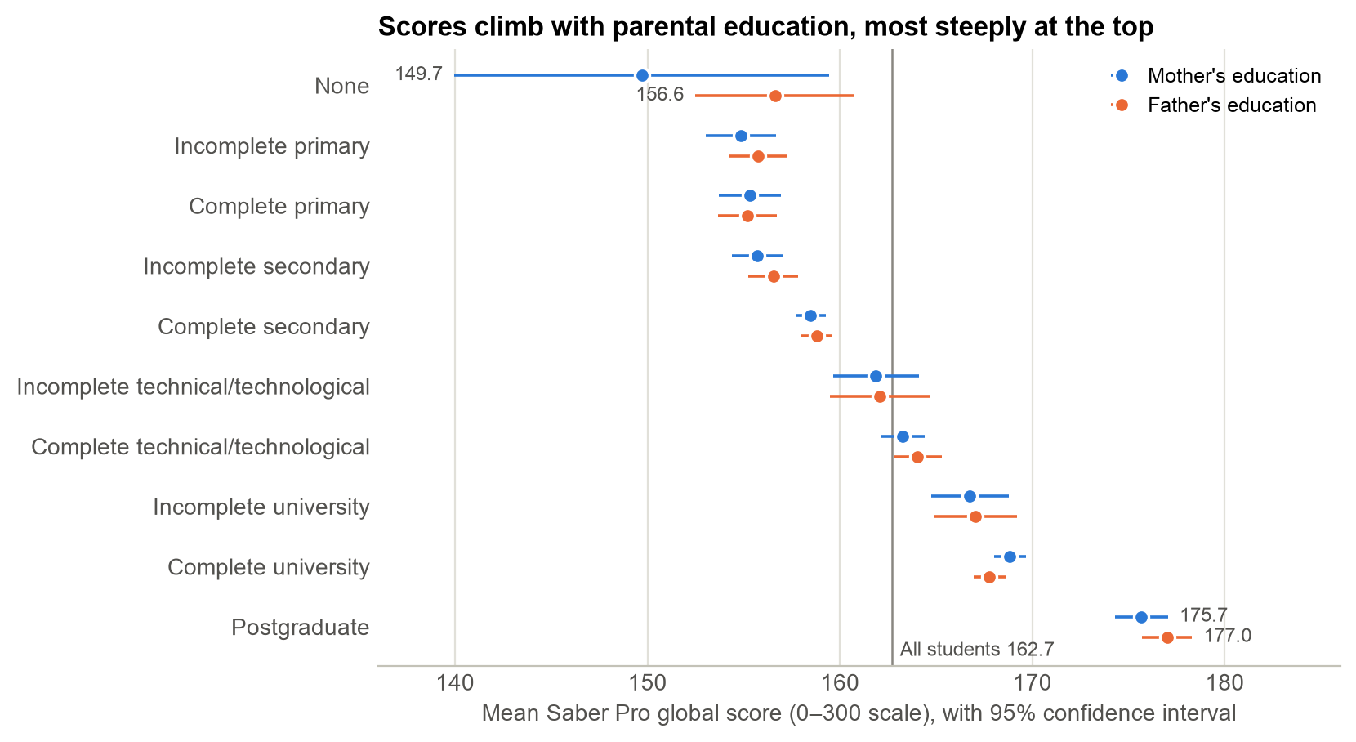
Fig. 1. Mean Saber Pro global score by mother’s and father’s education, with 95% confidence intervals and the all-student mean of 162.7; author’s chart from data_academic_performance.xlsx (De La Hoz).
Students whose more-educated parent holds a postgraduate degree average 175.28, against 154.39 for students whose parents have primary schooling or less (see table 3). The 20.89-point gap equals 0.95 standard deviations.
Table 3
Saber Pro Global Score by the Education of the More-Educated Parent
Parent’s education | Students | Share | Mean | Std. dev. | 95% confidence interval | Gap vs. primary or less | Cohen’s d
Primary or less | 918 | 7.7% | 154.39 | 22.00 | 152.96–155.81 | — | —
Secondary | 3,485 | 29.2% | 156.77 | 21.93 | 156.04–157.49 | +2.38 | 0.11
Technical or technological | 1,684 | 14.1% | 161.14 | 21.66 | 160.11–162.18 | +6.75 | 0.31
Some university | 451 | 3.8% | 164.18 | 22.55 | 162.10–166.27 | +9.80 | 0.44
University degree | 3,828 | 32.0% | 166.33 | 22.86 | 165.61–167.06 | +11.95 | 0.53
Postgraduate | 1,584 | 13.3% | 175.28 | 22.00 | 174.19–176.36 | +20.89 | 0.95
Source: Author’s calculations from data_academic_performance.xlsx (De La Hoz). The 445 students with no reported parental education are excluded.
The differences are far too large to be chance. Welch’s analysis of variance, which allows the groups to have unequal variances (Welch, “On the Comparison”), and the rank-based Kruskal–Wallis test (Kruskal and Wallis) both reject equal means (p < 0.001). Tukey’s honestly significant difference test, run in SciPy (Virtanen et al.), separates every pair of levels except three neighbors: primary or less and secondary differ only at p < 0.05, and the test cannot separate technical or technological from some university (p = 0.10) or some university from a university degree (p = 0.38).
How much parental education matters can be measured three ways:
- The raw gap: 20.9 points, or 0.95 standard deviations, from the lowest level to the highest.
- The share of variation explained: 7.6% (ω² = 0.076), a medium effect by Cohen’s benchmarks, in which 1% is small, 6% medium and 14% large (Cohen). Fathers’ and mothers’ education explain almost the same share (7.6% and 7.4%).
- First-generation students: the 4,403 students whose parents did not study beyond secondary school, 36.8% of those with a reported parent, score 10.7 points lower than their peers (156.3 against 166.9; d = −0.47).
Much of this influence is shared with the rest of family background. Holding gender, stratum, family income and type of high school constant, a postgraduate parent is still associated with 9.3 more points. Once Saber 11 results are also held constant, that gap shrinks to 1.3 points and is no longer statistically significant (see “From High School to University” below).

Question 2: Which Stratum Performs Best, and Do Strata Differ?
Stratum 6 performs best, with a mean global score of 181.51, and the mean rises at every step from stratum 1 (152.39) (see table 4). The 29.1-point gap between strata 6 and 1 is a very large effect (Cohen’s d = 1.33), and stratum explains about 10% of the variation in the global score (ω² = 0.103).
Table 4
Saber Pro Global Score by Socioeconomic Stratum
Stratum | Students | Share | Mean | Std. dev. | Median | 95% confidence interval | Gap vs. stratum 1 | In national top quarter
1 | 1,707 | 13.8% | 152.39 | 21.92 | 152 | 151.35–153.43 | — | 31.9%
2 | 4,026 | 32.5% | 158.21 | 22.28 | 158 | 157.52–158.90 | +5.82 | 42.5%
3 | 4,039 | 32.6% | 163.81 | 21.69 | 164 | 163.14–164.48 | +11.43 | 53.0%
4 | 1,575 | 12.7% | 172.03 | 21.48 | 174 | 170.97–173.09 | +19.65 | 69.1%
5 | 631 | 5.1% | 177.47 | 21.49 | 179 | 175.79–179.15 | +25.09 | 77.7%
6 | 403 | 3.3% | 181.51 | 21.88 | 184 | 179.37–183.65 | +29.12 | 82.4%
Source: Author’s calculations from data_academic_performance.xlsx (De La Hoz). Fourteen students with no stratum recorded are excluded. The national top quarter is a global score of 163 or more, the top category of the file’s national quartile variable.
The differences are real and not driven by a few unusual students. A classic analysis of variance, Welch’s analysis of variance and the Kruskal–Wallis test all reject equal means (p < 0.001). Tukey’s test separates every pair of strata at p < 0.001 except the top two: strata 5 and 6 differ by 4.0 points (p = 0.04).
The strata still overlap heavily (see fig. 2). Of stratum-1 students, 31.9% reach the national top quarter, while 17.6% of stratum-6 students fall below it. A student’s stratum shifts the odds; it does not decide the result.
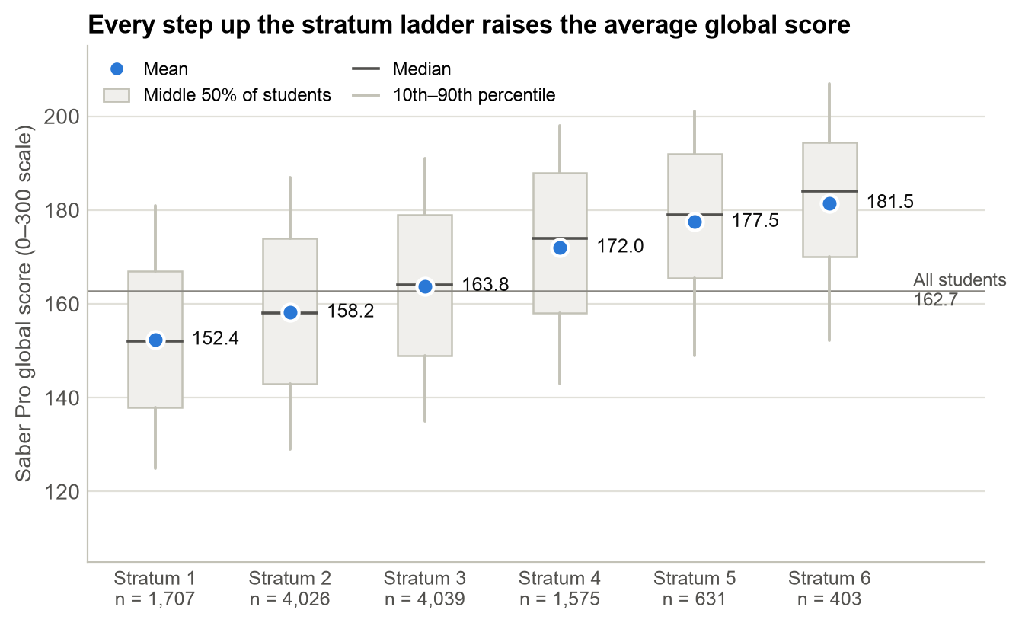
Fig. 2. Saber Pro global score by stratum: mean, median, middle 50% and 10th to 90th percentiles of students, with the all-student mean of 162.7; author’s chart from data_academic_performance.xlsx (De La Hoz).
The gap is concentrated in English (see fig. 3). The mean national percentile in Saber Pro English climbs from 50.9 in stratum 1 to 92.5 in stratum 6, a 41.5-point rise. Stratum explains 18% of its variation, about four times its share in quantitative reasoning, critical reading or citizenship competencies (4% each). The gap starts in high school, where stratum explains 25% of the variation in Saber 11 English, and it is smallest in written communication and engineering projects (2% each).
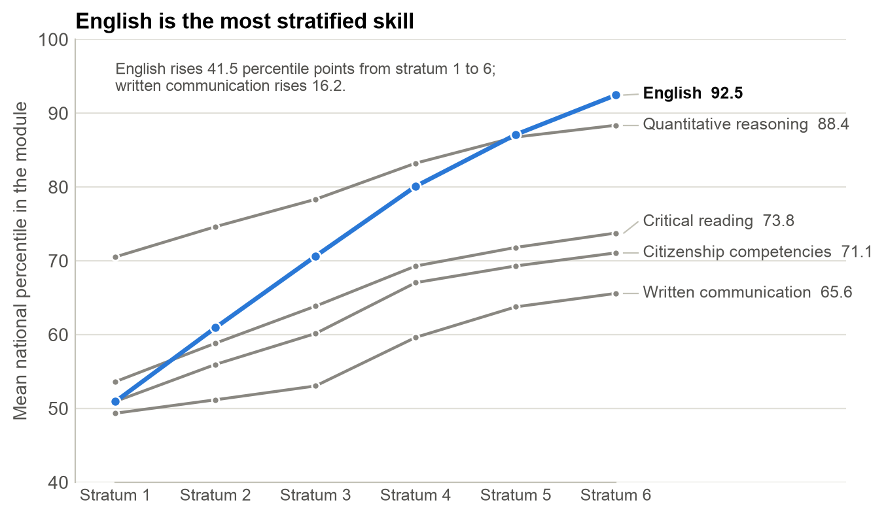
Fig. 3. Mean national percentile in each Saber Pro generic module, by stratum; author’s chart from data_academic_performance.xlsx (De La Hoz).
Stratum is bound up with the rest of family background. Parental education rises with stratum (Spearman’s ρ = 0.47): 20.7% of stratum-1 students have parents with primary schooling or less, against none in stratum 6, where 45.6% have a parent with a postgraduate degree. And 87.5% of stratum-1 students attended a public high school, against 0.5% in stratum 6.

Question 3: How Does Each Gender Perform on the Global Assessment?
On the global assessment, the Saber Pro global score, women and men perform almost identically: women average 161.30 and men 163.70, a gap of 2.4 points on a 300-point scale (see table 5). The gap is statistically significant. Welch’s t-test, which does not assume equal variances (Welch, “Generalization”), gives t = −5.72 and p < 0.001, and the Mann–Whitney U test, which compares ranks rather than means (Mann and Whitney), agrees. But the gap is negligible in size (Cohen’s d = −0.10, half the 0.2 that Cohen calls small) and is detectable only because the sample is large. Men are slightly more likely to reach the national top quarter (52.7% against 48.3%).
The small gap is about the same in every stratum, from 1.2 to 3.7 points, and it disappears for students who entered university with the same Saber 11 scores. Holding those constant, women score 0.4 points higher than men (95% confidence interval −0.1 to 0.9; p = 0.15).
Table 5
Mean Scores of Women and Men by Subject
Exam | Subject | Women | Men | Women − men | Cohen’s d | p-value
Saber 11 | Mathematics | 61.94 | 65.96 | −4.01 | −0.34 | <0.001
 | Critical reading | 60.91 | 60.70 | +0.20 | +0.02 | 0.264
 | Citizenship competencies | 59.97 | 61.22 | −1.25 | −0.12 | <0.001
 | Biology | 62.28 | 65.11 | −2.83 | −0.26 | <0.001
 | English | 61.45 | 62.04 | −0.59 | −0.04 | 0.024
Saber Pro | Quantitative reasoning | 71.91 | 81.19 | −9.29 | −0.42 | <0.001
 | Critical reading | 61.36 | 62.80 | −1.44 | −0.05 | 0.004
 | Citizenship competencies | 58.60 | 59.61 | −1.01 | −0.03 | 0.054
 | English | 66.54 | 68.16 | −1.62 | −0.06 | <0.001
 | Written communication | 56.66 | 51.71 | +4.95 | +0.17 | <0.001
 | Engineering projects | 145.31 | 145.62 | −0.32 | −0.01 | 0.661
 | Global score | 161.30 | 163.70 | −2.39 | −0.10 | <0.001
Source: Author’s calculations from data_academic_performance.xlsx (De La Hoz), for 5,036 women and 7,359 men. The p-values are from Welch’s t-test. The Saber Pro modules other than engineering projects and the global score are national percentiles.
The near-parity hides two opposite gaps by subject (see fig. 4):
- Men lead in quantitative reasoning by 9.3 percentile points (d = −0.42), a wider gap than in high-school mathematics (d = −0.34). Women still trail by 4.7 points when compared with men who had the same Saber 11 mathematics score.
- Women lead in written communication by 5.0 percentile points (d = +0.17), and by 4.8 points among students with the same Saber 11 critical-reading score. Men are almost twice as likely to score zero on the essay (3.0% against 1.7%).
- Both gaps appear in every program group. The quantitative-reasoning gap ranges from 1.7 points in the smaller programs to 9.5 points in civil engineering, and the writing gap from 1.8 to 9.7 points (see app. B).
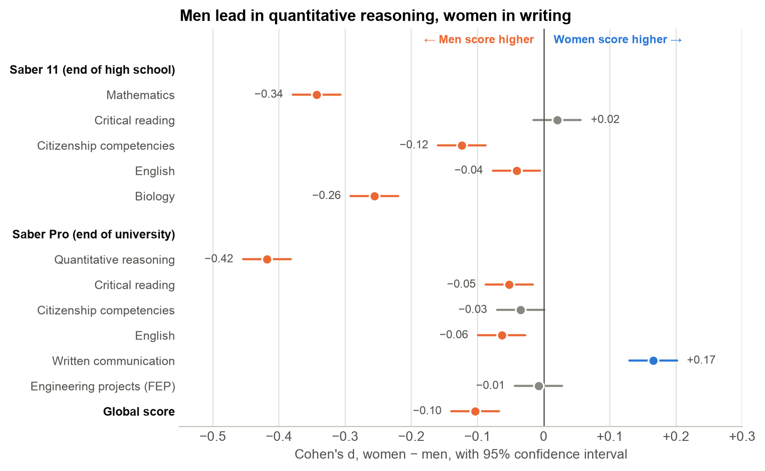
Fig. 4. Differences between women’s and men’s scores by subject, as Cohen’s d with 95% confidence intervals; negative values mean that men score higher; author’s chart from data_academic_performance.xlsx (De La Hoz).

Other Attributes: What Else Is Associated with Results?
To compare all the attributes on one scale, fig. 5 shows the share of the variation in the global score that each one explains on its own. Four findings stand out:
- High-school results matter most. The five Saber 11 scores together explain 61% of the variation, far more than any background attribute.
- Where students study matters. The university attended explains 39% on its own, although this partly reflects which students each university admits, and the institution’s socioeconomic level explains 14%.
- The economic attributes follow one gradient. Family income (11%), stratum (10%), parental education (8%), SISBEN classification (7%) and public or private high school (6%) each explain a similar share. Students from private high schools score 11.7 points higher than those from public ones (d = 0.52), and students from families earning 10 or more minimum wages score 30.4 points higher than those earning less than one.
- Some attributes matter little. Household size, work while studying and gender each explain 0.5% or less.
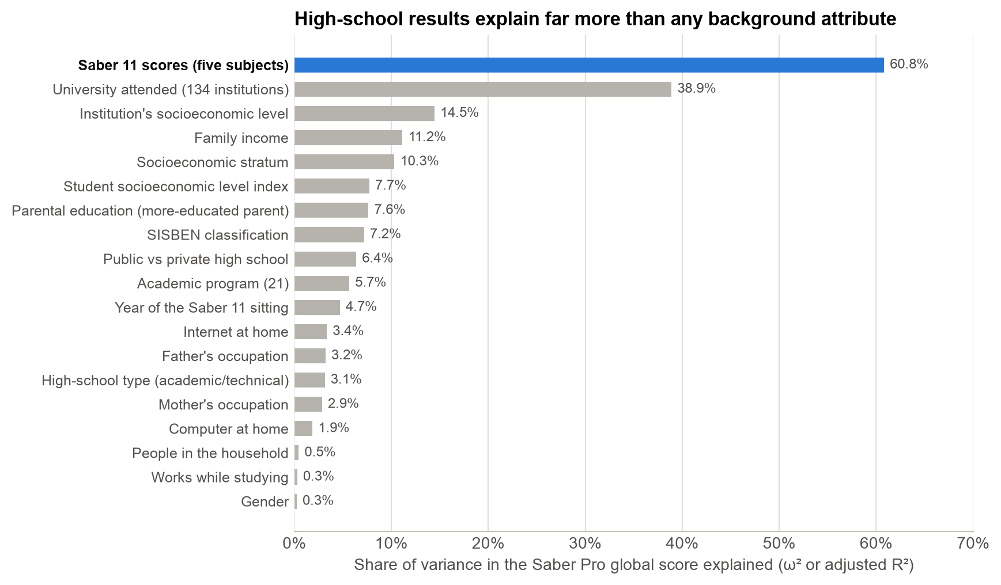
Fig. 5. Share of the variation in the Saber Pro global score that each attribute explains on its own (ω², or adjusted R² for the five Saber 11 scores together); author’s chart from data_academic_performance.xlsx (De La Hoz).
Programs and institutions differ in what they add. Comparing each student’s global score with the score predicted from their Saber 11 results gives a simple measure of value added (see app. B):
- Chemical engineering students finish 3.3 points above their predicted scores, the most of any program group, and mechanical engineering students finish 1.2 points below.
- Students at institutions in the lowest socioeconomic level (22 institutions, 1,137 students) finish 3.4 points below prediction, while those in the two highest levels finish 2.1 to 2.9 points above.
- Students who reached Saber Pro fastest, sitting Saber 11 in 2014, scored highest (175.8, against 158.1 for those who sat Saber 11 in 2012) and finished 2.6 points above prediction.

From High School to University
Background shapes where students start far more than how far they progress (see table 6 and fig. 6). Because the background attributes are entangled with each other and with high-school results, I fitted ordinary least squares models of the global score for the 11,695 students with complete data. The models use heteroskedasticity-robust (HC3) standard errors (MacKinnon and White), which remain reliable when the spread of scores differs between groups (Long and Ervin):
- Holding other background constant, each gap shrinks but remains: a postgraduate parent is associated with 9.3 more points, stratum 6 with 12.3 and the top income band with 13.1. Together, the background attributes explain 14.7% of the variation.
- Also holding the five Saber 11 scores constant lifts the share explained to 61.5%, and each of these gaps falls to between −0.2 and +1.3 points, none statistically different from zero. Each background attribute’s unique contribution falls to 0.03 percentage point of explained variation or less.
- Students keep their rank. Of the students in the bottom quarter on Saber 11, 69.8% finish in the bottom quarter on Saber Pro; 69.6% of those in the top quarter stay there, and only 0.4% move from the bottom quarter to the top.
Table 6
Gaps in the Global Score Before and After Holding Other Factors Constant
Comparison | Raw gap | Holding other background constant | Also holding Saber 11 scores constant
Parent with postgraduate degree vs. primary or less | +21.34 | +9.33 (7.37 to 11.29) | +1.26 (−0.05 to 2.58)
Stratum 6 vs. stratum 1 | +29.87 | +12.33 (9.45 to 15.21) | −0.23 (−2.37 to 1.92)
Family income of 10 or more vs. under 1 minimum wage | +30.33 | +13.13 (10.44 to 15.83) | +1.13 (−0.76 to 3.01)
Private vs. public high school | +11.78 | +3.76 (2.80 to 4.73) | +0.40 (−0.24 to 1.04)
Women vs. men | −2.47 | −2.13 (−2.92 to −1.35) | +0.34 (−0.20 to 0.88)
Source: Author’s estimates from data_academic_performance.xlsx (De La Hoz); ordinary least squares for the 11,695 students with complete data, with 95% confidence intervals from HC3 robust standard errors in parentheses. The raw gaps use the same students, so they differ slightly from tables 3 to 5. Full results are in appendix C.
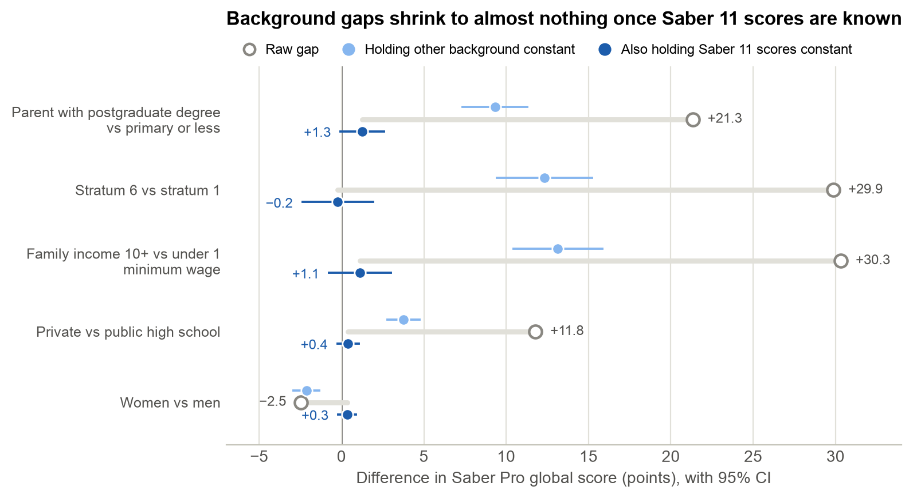
Fig. 6. Gaps in the Saber Pro global score before and after holding other background attributes and Saber 11 scores constant, with 95% confidence intervals; author’s chart from data_academic_performance.xlsx (De La Hoz).
Family background therefore influences engineering results mainly through the skills students bring from high school. University years carry the gaps forward; on average, they neither close them nor widen them.

Preferred Alternative and Rationale
I compared three ways of directing support against the decision criteria:
- A. Support by background: offer tutoring and other support at university to students from strata 1 and 2, or SISBEN levels 1 and 2.
- B. Support by Saber 11 results at university entry: use each student’s Saber 11 results to offer English, quantitative-reasoning and writing support to those who need it.
- C. Support by Saber 11 results from high school onward: strategy B, plus English and mathematics support in high schools that serve strata 1 and 2.
Table 7 tests the targeting rules behind these strategies. A rule based on the Saber 11 average flags 3,150 students, 2,583 fewer than a rule based on stratum, yet it reaches more of the students who finish in the bottom quarter (67.5% against 62.2%). And 69.8% of the students it flags end there, against 35.4% for the stratum rule.
Table 7
How Well Each Targeting Rule Finds the Students Who Finish in the Bottom Quarter
Targeting rule | Students flagged | Share of students | Precision | Coverage
Stratum 1 or 2 | 5,733 | 46.3% | 35.4% | 62.2%
SISBEN level 1 or 2 | 4,173 | 33.7% | 39.1% | 50.0%
First-generation student | 4,403 | 35.5% | 35.3% | 47.8%
Public high school | 5,840 | 47.1% | 34.5% | 61.8%
Bottom quarter of Saber 11 English | 3,210 | 25.9% | 57.8% | 56.9%
Bottom quarter of Saber 11 average | 3,150 | 25.4% | 69.8% | 67.5%
Source: Author’s calculations from data_academic_performance.xlsx (De La Hoz). The bottom quarter is the 3,258 students (26.3%) with a global score of 147 or less. Precision is the share of flagged students who finish in the bottom quarter; coverage is the share of bottom-quarter students who are flagged.
Table 8
Three Strategies Compared against the Decision Criteria
Criterion | A. Support by background | B. Support by Saber 11 results at university entry | C. Support by Saber 11 results from high school onward
Coverage | 62.2% of bottom-quarter students | 67.5% | 67.5% at university, plus students reached before Saber 11
Precision | 35.4% | 69.8% | 69.8% at university
Size of the problem addressed | Background gaps, which vanish once Saber 11 results are known | Skills that explain 61% of the variation | The same skills, where the gaps form
Timing | After the gaps have formed | After the gaps have formed | Before and after university entry
Cost and feasibility | Uses strata or SISBEN data; serves 5,733 students | Uses Saber 11 scores already on record; serves 3,150 students | Adds a high-school program, so it costs the most
Measurability | Testable against Saber Pro | Testable against Saber Pro | Testable, but the high-school part takes years to reach Saber Pro
Source: Author’s analysis of data_academic_performance.xlsx (De La Hoz). Coverage and precision come from table 7 (the stratum rule for A and the Saber 11 average rule for B and C); cost and feasibility are the author’s judgment.
Strategy C is the preferred alternative. It acts on the skills that explain most of the variation in results, it targets them twice as precisely as support by background, and its high-school component reaches the gaps where they form. Its university component, strategy B, can start at once with data the system already holds, and its high-school component addresses English, the skill in which the gap between strata is widest at the end of high school.
The economic rationale is about where each peso goes. For a fixed cost per student served, targeting by Saber 11 results serves 45% fewer students than targeting by stratum, yet it reaches about 170 more of the students who finish in the bottom quarter. The money that background-based support would spend on students who do not need it can pay for the high-school component.
Strategy A fails on precision: almost two-thirds of the students it would serve (64.6%) do not finish in the bottom quarter, and once Saber 11 results are known, background adds almost nothing to the prediction. Background still has a role in strategy C, however. Strata and SISBEN can decide where the high-school programs go, because 87.5% of stratum-1 students attended a public high school and English skills differ most across strata.

Recommendations and Predicted Outcome
I recommend that the Department of Education take five steps:
- Screen every entering engineering student with Saber 11 results. Offer academic support to the bottom quarter on the Saber 11 average, and English support to the bottom quarter in Saber 11 English. The scores already exist for every student, so screening costs little.
- Fund English and mathematics in high schools that serve strata 1 and 2. English is the most unequal skill at the end of high school. Each Saber 11 English point is also associated with 0.45 more global-score points, the largest coefficient of any subject (0.29 for mathematics), with background and the other subjects held constant.
- Address the subject gaps between women and men in every program. Offer quantitative-reasoning support and encourage women to use it, starting in civil and industrial engineering, where women trail by 9.5 and 8.7 percentile points. Offer writing support to men, who are almost twice as likely to score zero on the essay.
- Learn from the programs and institutions that add the most. Study the practices of chemical engineering (3.3 points of value added) and of the institutions in the two highest socioeconomic levels. Direct improvement funds to the 22 institutions in the lowest level, whose students finish 3.4 points below prediction.
- Test before scaling. Pilot each measure with a comparison group of similar students, and judge it by the change in Saber Pro results.
The effect of the high-school component can be sized with model M3, which holds background constant (see table 9). Students in strata 1 and 2 average 156.5 on the global score, 11.7 points below students in strata 3 to 6, and 2,027 of them finish in the bottom quarter. Suppose support raised their Saber 11 English and mathematics scores by 5 points each, about a third of a standard deviation in English and two-fifths in mathematics. The model then predicts a 3.73-point rise in their mean global score, which would close 32.0% of the gap and lift about 388 students out of the bottom quarter. English contributes more than mathematics: 5 points of English alone would close 19.5% of the gap.
Table 9
Predicted Effect of Higher Saber 11 Scores for the 5,733 Students in Strata 1 and 2
Scenario | Saber 11 gain | Predicted rise in global score | Share of the 11.7-point gap closed | Students leaving the bottom quarter
English only | 5 points | 2.27 | 19.5% | 293
Mathematics only | 5 points | 1.46 | 12.6% | 204
Conservative: English and mathematics | 3 points each | 2.24 | 19.2% | 293
Moderate: English and mathematics | 5 points each | 3.73 | 32.0% | 388
Strong: English and mathematics | 8 points each | 5.96 | 51.1% | 557
Source: Author’s calculations from data_academic_performance.xlsx (De La Hoz), using model M3 (app. C), with scores capped at 100. The gap is between the mean global scores of strata 1 and 2 (156.5) and strata 3 to 6 (168.1). The bottom quarter is a global score of 147 or less; 2,027 students in strata 1 and 2 are in it now.
These estimates are associations, not forecasts. Students with higher Saber 11 scores may differ in ways the data do not record, so a program that raised scores could yield smaller gains than the model predicts. The pilots in step 5 are needed to measure the true effect before the department scales any program up.

Conclusion
Engineering students’ results on Saber Pro rise steadily with their family’s socioeconomic position. A postgraduate parent goes with a global score 20.9 points higher than parents with primary schooling or less, stratum 6 averages 29.1 points more than stratum 1, and every stratum differs from the next. Women and men score almost the same overall, although men lead in quantitative reasoning and women in written communication.
The central finding is that these gaps are already in place when students leave high school. Saber 11 results explain 61% of the variation in Saber Pro scores, and once they are known, background adds almost nothing. University carries the gaps forward without closing them.
The Department of Education should therefore direct support by measured skills rather than by background. It should screen entering students with their Saber 11 results, invest in English and mathematics in high schools that serve strata 1 and 2, address the subject gaps between women and men, and test each step against later Saber Pro results. Under moderate assumptions, the high-school component alone would close about a third of the gap between students in strata 1 and 2 and their peers.

Works Cited
Cohen, Jacob. Statistical Power Analysis for the Behavioral Sciences. 2nd ed., Lawrence Erlbaum Associates, 1988.
De La Hoz, Enrique. “Data of Academic Performance Evolution for Engineering Students.” Mendeley Data, version 1, 10 Feb. 2020, https://doi.org/10.17632/83tcx8psxv.1.
Delahoz-Dominguez, Enrique, et al. “Dataset of Academic Performance Evolution for Engineering Students.” Data in Brief, vol. 30, 2020, article 105537, https://doi.org/10.1016/j.dib.2020.105537.
“Estratificación socioeconómica para servicios públicos domiciliarios.” Departamento Administrativo Nacional de Estadística, www.dane.gov.co/index.php/servicios-al-ciudadano/servicios-informacion/estratificacion-socioeconomica. Accessed 9 Nov. 2026.
Harris, Charles R., et al. “Array Programming with NumPy.” Nature, vol. 585, no. 7825, 2020, pp. 357–62, https://doi.org/10.1038/s41586-020-2649-2.
Hunter, John D. “Matplotlib: A 2D Graphics Environment.” Computing in Science & Engineering, vol. 9, no. 3, 2007, pp. 90–95, https://doi.org/10.1109/MCSE.2007.55.
Kruskal, William H., and W. Allen Wallis. “Use of Ranks in One-Criterion Variance Analysis.” Journal of the American Statistical Association, vol. 47, no. 260, 1952, pp. 583–621, https://doi.org/10.1080/01621459.1952.10483441.
Long, J. Scott, and Laurie H. Ervin. “Using Heteroscedasticity Consistent Standard Errors in the Linear Regression Model.” The American Statistician, vol. 54, no. 3, 2000, pp. 217–24, https://doi.org/10.1080/00031305.2000.10474549.
MacKinnon, James G., and Halbert White. “Some Heteroskedasticity-Consistent Covariance Matrix Estimators with Improved Finite Sample Properties.” Journal of Econometrics, vol. 29, no. 3, 1985, pp. 305–25, https://doi.org/10.1016/0304-4076(85)90158-7.
Mann, H. B., and D. R. Whitney. “On a Test of Whether One of Two Random Variables Is Stochastically Larger than the Other.” The Annals of Mathematical Statistics, vol. 18, no. 1, 1947, pp. 50–60, https://doi.org/10.1214/aoms/1177730491.
McKinney, Wes. “Data Structures for Statistical Computing in Python.” Proceedings of the 9th Python in Science Conference, edited by Stéfan van der Walt and Jarrod Millman, 2010, pp. 56–61, https://doi.org/10.25080/Majora-92bf1922-00a.
Virtanen, Pauli, et al. “SciPy 1.0: Fundamental Algorithms for Scientific Computing in Python.” Nature Methods, vol. 17, no. 3, 2020, pp. 261–72, https://doi.org/10.1038/s41592-019-0686-2.
Welch, B. L. “The Generalization of ‘Student’s’ Problem When Several Different Population Variances Are Involved.” Biometrika, vol. 34, nos. 1–2, 1947, pp. 28–35, https://doi.org/10.1093/biomet/34.1-2.28.
---. “On the Comparison of Several Mean Values: An Alternative Approach.” Biometrika, vol. 38, nos. 3–4, 1951, pp. 330–36, https://doi.org/10.1093/biomet/38.3-4.330.

Appendix A: Data, Cleaning, and the Notebook
Variables used. Table 10 lists the variables the analysis uses. The file also records parents’ occupations, household items such as internet access, a computer and a car, and school and university names; the notebook uses some of them as secondary attributes.
Table 10
Variables in data_academic_performance.xlsx Used in the Analysis
Variable | Description | Used for
MAT_S11, CR_S11, CC_S11, BIO_S11, ENG_S11 | Saber 11 scores in mathematics, critical reading, citizenship competencies, biology and English (0–100) | Summaries, models and targeting
QR_PRO, CR_PRO, CC_PRO, ENG_PRO, WC_PRO | Saber Pro generic modules in quantitative reasoning, critical reading, citizenship competencies, English and written communication (national percentiles) | Summaries by category and question 3
FEP_PRO | Saber Pro module on formulating engineering projects (0–300) | Summaries
G_SC | Saber Pro global score (0–300) | Main outcome
QUARTILE | National quartile of the global score | Top-quarter shares
GENDER | F or M | Question 3
EDU_FATHER, EDU_MOTHER | Father’s and mother’s education | Question 1
STRATUM | Socioeconomic stratum of the home (1–6) | Question 2
SISBEN | SISBEN classification | Other attributes and targeting
REVENUE | Family income, in bands of the monthly minimum wage | Other attributes and models
SCHOOL_NAT, SCHOOL_TYPE | Public or private high school; academic or technical | Other attributes and models
UNIVERSITY, SEL_IHE | University attended and its socioeconomic level (1–4) | Institutions and value added
ACADEMIC_PROGRAM | Engineering program (21 in the data) | Programs and value added
COD_S11, Cod_SPro | Codes of the Saber 11 and Saber Pro records | Duplicates and exam years
Source: Data definitions in data_academic_performance.xlsx (De La Hoz); descriptions are the author’s.
Cleaning. Sections 3 and 4 of the notebook check the file before any analysis. The notebook drops one empty column, treats “0” and “Not sure” as missing, translates the remaining Spanish labels (Ninguno = none, Nueve = nine, Once = eleven), and orders every ordinal category from lowest to highest. It removes the 16 duplicate Saber Pro records by keeping each student’s earlier Saber 11 sitting, which leaves 12,395 students. It also derives the education of the more-educated parent, grouped into six levels; first-generation status; the Saber 11 average; the year of the Saber 11 sitting; and a program variable that groups the 15 smallest programs together.
Running the notebook. The notebook runs from top to bottom in Google Colab (Runtime → Run all) or Jupyter with no setup. If the workbook is not in its folder, it downloads the identical file from the project’s public GitHub repository, github.com/Shibainulove/6070-001-202630, and checks its SHA-256 fingerprint. It uses pandas, NumPy, SciPy and Matplotlib, plus openpyxl to read the workbook, and it gives the same results with Python 3.9 and Python 3.14. Section 5 summarizes the attributes by category, sections 6 to 8 answer questions 1 to 3, sections 9 and 10 cover the other attributes and the models, and section 12 holds the calculations behind tables 7 and 9.

Appendix B: Results by Program and Institution
Table 11 compares the six largest engineering programs and the other 15 grouped together. Value added is the mean difference between students’ global scores and the scores predicted from their five Saber 11 scores.
Table 11
Results by Academic Program
Program | Students | Women | First-generation | Saber 11 average | Mean global score | Value added | QR | English | WC
Industrial engineering | 5,315 | 51.9% | 38.0% | 60.5 | 159.1 | −0.5 | 72.1 | 64.7 | 54.2
Civil engineering | 3,310 | 35.9% | 36.0% | 61.4 | 161.1 | +0.2 | 78.8 | 63.8 | 51.3
Mechanical engineering | 1,133 | 12.0% | 35.8% | 64.8 | 166.0 | −1.2 | 82.7 | 72.3 | 50.5
Chemical engineering | 1,000 | 54.5% | 27.0% | 68.0 | 176.7 | +3.3 | 86.9 | 82.5 | 64.0
Electronic engineering | 848 | 19.6% | 38.5% | 65.1 | 166.9 | −0.9 | 82.1 | 73.0 | 51.2
Electric engineering | 278 | 21.9% | 37.9% | 68.0 | 174.0 | +1.0 | 88.7 | 76.1 | 57.8
Other programs (15) | 511 | 35.0% | 49.6% | 62.3 | 163.4 | +0.8 | 79.2 | 66.7 | 53.5
Source: Author’s calculations from data_academic_performance.xlsx (De La Hoz). QR, English and WC are the mean national percentiles in quantitative reasoning, English and written communication.
Table 12
Gaps between Women and Men in Quantitative Reasoning and Written Communication, by Program
Program | Students | Women | Quantitative reasoning gap | Written communication gap
Industrial engineering | 5,315 | 51.9% | −8.7 | +3.4
Civil engineering | 3,310 | 35.9% | −9.5 | +3.6
Mechanical engineering | 1,133 | 12.0% | −3.8 | +4.1
Chemical engineering | 1,000 | 54.5% | −6.7 | +6.5
Electronic engineering | 848 | 19.6% | −8.1 | +5.8
Electric engineering | 278 | 21.9% | −6.3 | +1.8
Other programs (15) | 511 | 35.0% | −1.7 | +9.7
Source: Author’s calculations from data_academic_performance.xlsx (De La Hoz). Gaps are women’s mean national percentile minus men’s; negative values mean that men score higher.
Institutions at the lowest socioeconomic level enroll the poorest students (mean stratum 1.9), and theirs are the only students who finish well below the scores predicted from their Saber 11 results (see table 13).
Table 13
Results by the Socioeconomic Level of the Institution
Institution’s level (1 = lowest) | Institutions | Students | Mean stratum | Saber 11 average | Mean global score | Value added
1 | 22 | 1,137 | 1.9 | 59.2 | 153.1 | −3.4
2 | 92 | 7,736 | 2.5 | 60.3 | 158.3 | −0.5
3 | 8 | 833 | 2.9 | 61.8 | 164.8 | +2.9
4 | 12 | 2,689 | 3.7 | 69.6 | 178.8 | +2.1
Source: Author’s calculations from data_academic_performance.xlsx (De La Hoz). The level is the file’s SEL_IHE variable.

Appendix C: The Regression Models
To separate the background attributes from one another and from high-school results, I fitted four nested ordinary least squares models of the global score for the same 11,695 students with complete data (see table 14). Model M1 includes parental education only; M2 adds gender, stratum, family income and type of high school; M3 adds the five Saber 11 scores; and M4 adds academic program. The standard errors are heteroskedasticity-robust HC3 errors (MacKinnon and White).
Table 14
Ordinary Least Squares Models of the Saber Pro Global Score, Selected Coefficients
Term | M1 | M2 | M3 | M4
Parent: secondary | 2.66** (0.82) | 1.42 (0.81) | 0.21 (0.54) | 0.26 (0.53)
Parent: technical or technological | 6.95*** (0.91) | 3.76*** (0.91) | 0.20 (0.60) | 0.25 (0.60)
Parent: some university | 10.33*** (1.27) | 5.22*** (1.26) | 0.33 (0.89) | 0.37 (0.88)
Parent: university degree | 12.03*** (0.83) | 4.20*** (0.86) | 0.26 (0.57) | 0.32 (0.57)
Parent: postgraduate | 21.34*** (0.93) | 9.33*** (1.00) | 1.26 (0.67) | 1.28 (0.67)
Woman |  | −2.13*** (0.40) | 0.34 (0.27) | 0.10 (0.28)
Stratum 3 |  | 5.88*** (0.75) | 1.10* (0.50) | 0.98* (0.50)
Stratum 6 |  | 12.33*** (1.47) | −0.23 (1.10) | 0.09 (1.10)
Family income of 10 or more minimum wages |  | 13.13*** (1.38) | 1.13 (0.96) | 1.09 (0.96)
Private high school |  | 3.76*** (0.49) | 0.40 (0.33) | 0.32 (0.33)
Saber 11 mathematics |  |  | 0.29*** (0.02) | 0.29*** (0.02)
Saber 11 critical reading |  |  | 0.40*** (0.02) | 0.40*** (0.02)
Saber 11 citizenship competencies |  |  | 0.35*** (0.02) | 0.34*** (0.02)
Saber 11 biology |  |  | 0.35*** (0.02) | 0.34*** (0.02)
Saber 11 English |  |  | 0.45*** (0.01) | 0.45*** (0.01)
R² | 0.077 | 0.147 | 0.615 | 0.617
Adjusted R² | 0.076 | 0.146 | 0.614 | 0.616
Students | 11,695 | 11,695 | 11,695 | 11,695
Source: Author’s estimates from data_academic_performance.xlsx (De La Hoz); HC3 robust standard errors in parentheses; * p < 0.05, ** p < 0.01, *** p < 0.001. Reference groups: a parent with primary schooling or less, men, stratum 1, family income below one minimum wage, public high school and industrial engineering. Every model includes an intercept; the other strata, income bands and programs are in section 10 of the notebook.
Three results matter for this report:
- Background matters before Saber 11 is known. In M2, the top levels of parental education, stratum and family income all keep large, significant gaps, and together the background attributes explain 14.7% of the variation.
- Saber 11 scores absorb the background gaps. In M3, the five Saber 11 scores raise the share explained to 61.5%, and only strata 2 and 3 remain significant, by about 1 point each.
- Programs add little overall. M4 raises the share explained only from 61.5% to 61.7%, although chemical engineering students score 3.9 points more than industrial engineering students with the same background and Saber 11 scores.

